Git Cherry pick

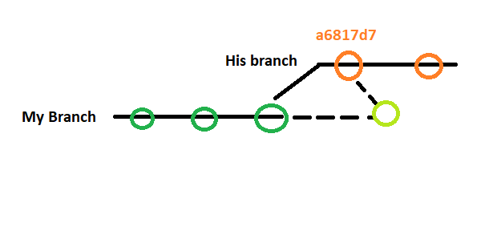

Steps cherry-pick with commit:

1. Switch to ***His branch –*** get the id of the commit that you want
2. Switch back to **My Branch**
3. **Execute: git cherry-pick a6817d7**
4. **Execute: git log**
5. You will see the **commit** but it will have a different **commit id** on your branch (**My Branch**)
6. You can cherry-pick multiple commits by leaving a space for example: **Execute:** git cherry-pick **a6817d7 deefb1 ccd12b**

Steps cherry-pick without commit:

3. Execute: git cherry-pick a6817d7 -n

4. Execute: git add .

5. Execute: git commit -m “Cherry pick”